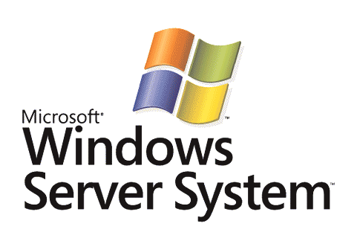

FrontBridge Email Protection: Technical Overview

Microsoft Corporation
Published: October 10, 2005

Abstract
FrontBridge offers fully managed services that provide email protection and message management to enterprises worldwide. FrontBridge runs a globally deployed and distributed network of eight data centers through which it provides managed anti-spam, anti-virus, and policy enforcement services to create a secure, protected, and compliant message stream. This white paper provides an overview of the FrontBridge E-Mail Filtering services along with the administrative controls and reporting capabilities built-in to the managed service system.



The information contained in this document represents the current view of Microsoft Corporation on the issues discussed as of the date of publication. Because Microsoft must respond to changing market conditions, it should not be interpreted to be a commitment on the part of Microsoft, and Microsoft cannot guarantee the accuracy of any information presented after the date of publication.
This White Paper is for informational purposes only. MICROSOFT MAKES NO WARRANTIES, EXPRESS, IMPLIED OR STATUTORY, AS TO THE INFORMATION IN THIS DOCUMENT.
Complying with all applicable copyright laws is the responsibility of the user. Without limiting the rights under copyright, no part of this document may be reproduced, stored in or introduced into a retrieval system, or transmitted in any form or by any means (electronic, mechanical, photocopying, recording, or otherwise), or for any purpose, without the express written permission of Microsoft Corporation.
Microsoft may have patents, patent applications, trademarks, copyrights, or other intellectual property rights covering subject matter in this document. Except as expressly provided in any written license agreement from Microsoft, the furnishing of this document does not give you any license to these patents, trademarks, copyrights, or other intellectual property.
Unless otherwise noted, the example companies, organizations, products, domain names, e-mail addresses, logos, people, places, and events depicted herein are fictitious, and no association with any real company, organization, product, domain name, email address, logo, person, place, or event is intended or should be inferred.
© 2005 Microsoft Corporation. All rights reserved.
Microsoft and FrontBridge are either registered trademarks or trademarks of Microsoft Corporation in the United States and/or other countries.
All other trademarks are property of their respective owners.

Contents
Introduction 1
Email Protection Services 2
Directory Services 3
FrontBridge Anti-Spam Service 5
FrontBridge Virus Management 9
Policy Enforcement 10
Disaster Recovery 12
FrontBridge’s Global Customer Support Center (GCSC) 13
Implementation and Administration 14
About FrontBridge Technologies, a Microsoft Subsidiary 17
Related Links 18

Introduction
FrontBridge offers fully managed services that provide email protection and message management to enterprises worldwide. By deploying multiple layers of technology between the Internet and corporate networks, FrontBridge manages the inbound and outbound flow of email passing through mail gateways, guarding networks and corporate email systems against attacks by viruses, spam, and other malicious content. FrontBridge not only alleviates the headache of software ownership and maintenance, but also continuously optimizes network performance, updates virus definitions and spam blocking rules, and monitors system behavior and operation. As a result, FrontBridge’s customers can simply just “set it and forget it.”
FrontBridge runs a globally deployed and distributed network of eight data centers with fault-tolerant and redundant servers that are load balanced both site to site and internally within each data center. If any one data center is unavailable, traffic can be easily routed to another data center without any interruption to service. Further, FrontBridge’s algorithms analyze and route message traffic between data centers to ensure the most timely and efficient delivery. With this highly available network, FrontBridge thereby guarantees 99.999 percent uptime and has delivered historical uptime of 100%. No other message management service in the world can offer the same level of reliability.
This high level of availability allows FrontBridge to deliver unprecedented security. Some solution providers require both a primary mail exchange (MX) record, which resolves to the service network, and a secondary MX record, which resolves to the corporate email server as a backup. Some even require a third. FrontBridge, however, requires only one mail exchange (MX) record, which resolves to the FrontBridge network. Without a secondary or third MX record, the enterprise network can remain hidden from DNS lookups. Customers become invisible to malicious mailers because the DNS lookup points at FrontBridge instead of them. Customers therefore only accept inbound SMTP traffic from FrontBridge, closing the last remaining vulnerability in their network firewall.
Best of all, FrontBridge offers unparalleled ease of implementation. There is no need for enterprises to change or modify their existing email infrastructure, or install and maintain any new hardware or software. With a simple configuration change, customers can begin using FrontBridge services right away.
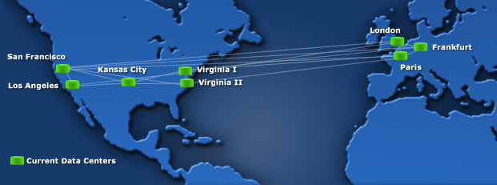
Figure 1-1: FrontBridge’s Globally Deployed Network

Email Protection Services
To provide effective message security for corporate networks, FrontBridge offers five services that apply a unique blend of preventive and protective measures to stop email-borne threats from infiltrating businesses and damaging productivity. The services are as follows:
Directory Services – Allows organizations to specify users for whom to accept email, as well as to define delivery groups and policies for intelligent routing which provides the ability to localize delivery so email is intelligently delivered to the most able corporate server that is closest to the recipient.
Spam Filtering – Prevents and protects corporate networks from spam via proprietary email traffic analysis technology, “fingerprinting,” rules-based scoring, and Custom Spam Filter Management (CSFM).
Virus Management – Protects businesses from receiving email-borne viruses and other malicious code by using multiple anti-virus engines, and employing Virus Hold to close the window of vulnerability during emerging threats.
Policy Enforcement – Filters messages according to the customer-defined rule set, allowing Administrators to block, quarantine, or redirect messages that violate those rules accordingly.
Disaster Recovery – Queues messages in the event of server unavailability and attempts redelivery every 15 minutes for a five-day period.
Developed as a family, these services easily integrate with one another as a package. And with no user tuning, FrontBridge’s fully scalable solution blocks more than 95 percent of unwanted email and 100 percent of known viruses, reducing message traffic and improving the efficiency of the corporate messaging infrastructure. Also, there are no white lists to upload or maintain. FrontBridge’s “set it and forget it” philosophy offloads management and maintenance of email protection from corporate IT staffs.
The following sections provide an overview of each service and how it works to secure corporate messaging networks.
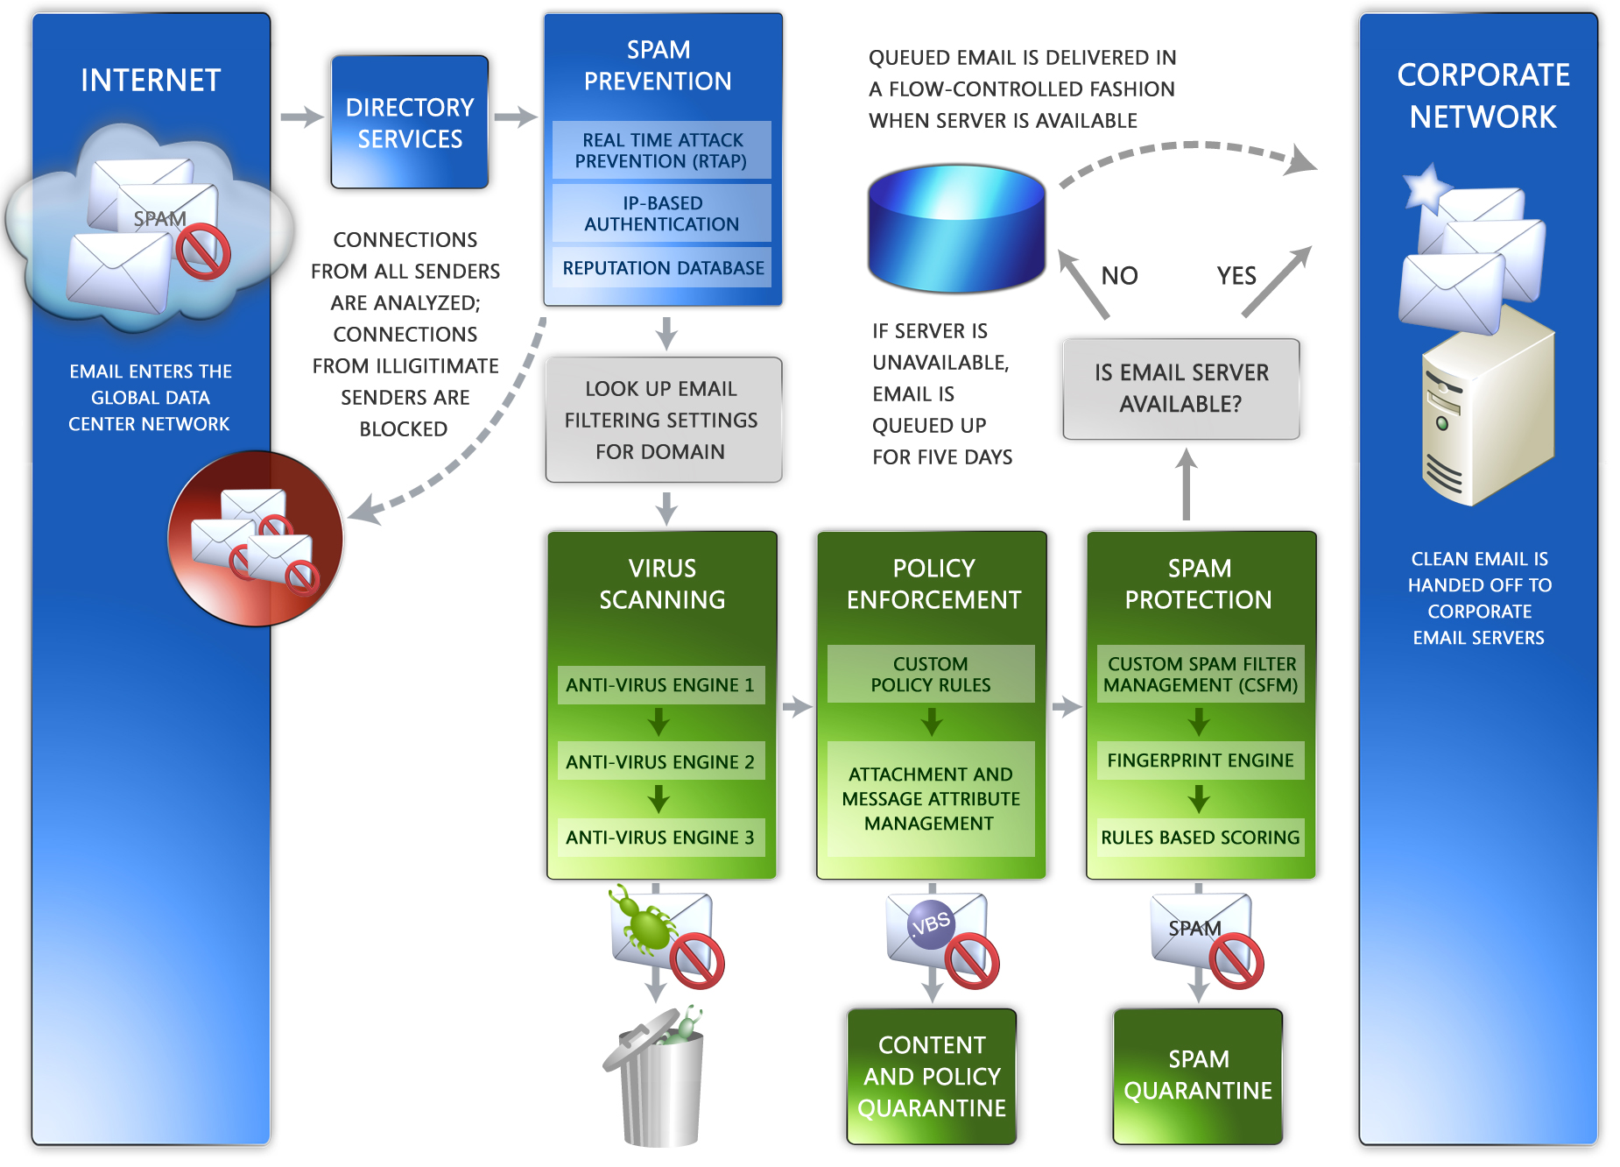
Figure 1-2: FrontBridge’s Integrated Family of Services

Directory Services
FrontBridge Directory Services is a multi-functional service that improves message handling and routing for inbound message traffic. By specifying who can accept email and defining delivery groups, customers leverage the Directory Services pre-emptive filter for messages, thereby improving the efficiency of their email infrastructure. Directory Services provides the Administrator with the ability to upload a user list, by domain, in the Admin Center. Incoming email is then compared to the domain user list and processed depending on the functionality chosen by the Administrator. By default, FrontBridge accepts mail for any SMTP address within a domain for which mail is processed. But with an uploaded user list, FrontBridge filters accordingly.
Features for Directory Services include message reject, pass through, reject test, group filtering, and intelligent routing.
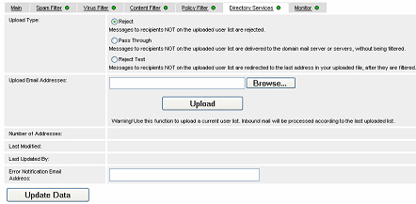
Figure 1-3: Directory Services Options in the Admin Center
Message Reject
This functionality rejects all email (spam and legitimate mail) at the network perimeter for recipients not on the domain’s user list. Therefore, if a message is received for a recipient that is included on the user list, the message is processed according to the domain’s settings. If, however, a message is received for a recipient who is not included on the user list, then FrontBridge responds with a 550 error message.
Pass Through
Administrators can define a subset of users who are “opted in” for service evaluation purposes, while all others by default are “opted out” of all filtering services, even if all users share the same domain. Therefore, if a message is received for a recipient included on the user list (that is, the end user is “opted in”), the message is processed according to the domain’s settings. If, however, a message is received for a recipient that is not included on the user list (that is, the end user is “opted out”) then the message bypasses the Message Switch and any filtering settings and is delivered to the corporate mail server directly.
Reject Test
To be used for short periods of time, this function validates the accuracy of a user list. All email for recipients not on a domain’s user list is redirected to a specific email address after filtering. Therefore, if a message is received for a recipient that is included on the user list, the message is processed according to the domain’s settings. If, however, a message is received for a recipient that is not included on the user list, then the message is processed according to the domain’s settings and delivered to the last email address listed for the domain.
Group Filtering
This functionality provides the ability for different groups of users to have their own set of filtering rules, even if all users share the same domain. (For example, the HR department can have different filtering rules than the IT department.) Each user included in the user list upload is associated with a group name. The Administrator then creates a virtual domain and configures it for each group name in the user list.
Intelligent Routing
A function of Group Filtering, this feature routes SMTP addresses to specific delivery locations based on group name and association, even if users all share the same domain. For example, the UK office can receive all mail for UK users at a specific location, one that is different than the destination for mail sent to US users. As in Group Filtering, each user is associated with a group, and each group is associated with a virtual domain. Each virtual domain is then configured to redirect email to specific servers within the organization.
Key translation servers or active trust brokering servers are required to interconnect one enterprise’s trusted servers with another. This can be prohibitively expensive and may also require establishing a trusted third-party intermediary.

FrontBridge Anti-Spam Service
Left unchecked, the scourge of spam can overwhelm businesses, destroying the productivity and benefits of this vital business communication tool. The sheer volume coupled with spammer creativity leaves businesses with no option but to turn to technology to combat this ever-present threat.

What is Spam?
The term “spam” typically refers to unsolicited “junk” email that is sent to large numbers of people to promote products or services. It can also refer to inappropriate promotional or commercial postings to discussion groups or bulletin boards.
FrontBridge defines an electronic message as spam if all of the following apply:
1. The recipient’s personal identity and context are irrelevant because the message is equally applicable to many other potential recipients.
2. The recipient has not verifiably granted deliberate, explicit, and still-revocable permission for it to be sent.
3. The transmission and reception of the message appears to give a disproportionate benefit to the sender.

How FrontBridge Protects Corporate Networks from Spam
FrontBridge achieves “best of breed” accuracy with proprietary, multi-layer spam technology that ensures unsolicited email is automatically filtered before it enters corporate messaging systems. There is no work or intervention needed by users or IT Administrators to incorporate FrontBridge’s anti-spam technology. This technology is applied at the domain level or sub domain level (for example, XYZ.COM, US.XYZ.COM, and UK.XYZ.COM). Using the Web-based Admin Center, Administrators can access the FrontBridge system to apply privileges and permissions at the domain or sub domain level.

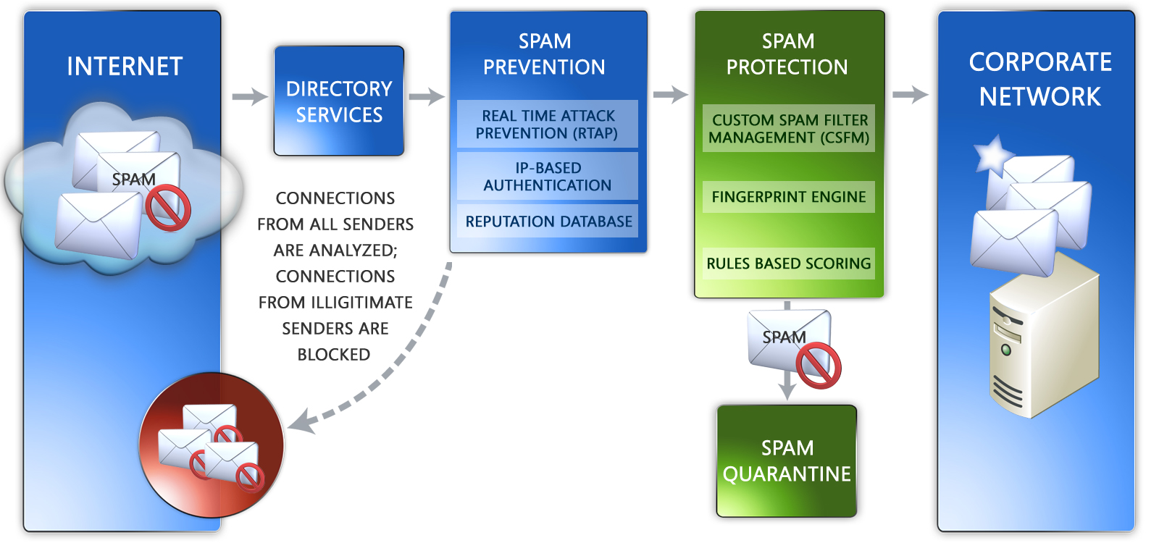

Figure 1-4: Spam Prevention and Protection

Spam Prevention
FrontBridge’s spam prevention gateway analyzes network traffic for anomalies, identifying behavioral patterns that indicate spam activity. Serving as the first line of defense against unwanted email, the FrontBridge spam prevention technology processes messages through three layers of advanced spam filtering: Real Time Attack Protection (RTAP), IP-based authentication, and the reputation database.
Real Time Attack Protection (RTAP): RTAP allows FrontBridge to protect customers against attempts of malice, such as dictionary attacks and mail bombs, by detecting suspicious patterns of email activity in real time. FrontBridge can automatically shut down connections from spammers and other attackers based on the analysis of inbound mail flow. RTAP monitors the frequency and integrity of inbound mail from various sources in order to block unwanted messages before these messages are passed to the filters for individual scanning. The end result is superior protection against illegitimate and potentially damaging email.
IP-based Authentication: FrontBridge authenticates the identity of the sender of each email. If the identity cannot be authenticated, the message is scored as likely spam. FrontBridge uses Sender Policy Framework (SPF), an industry standard that fights return-path address forgery by using return-path identity in email, making it easier to identify spoofs. SPF lookups help ensure email is coming from both a known sender and from whom it claims to be sent.
Reputation Database: FrontBridge’s reputation-based connection blocking employs a proprietary list that, based on analysis and historical perspective, contains the addresses of the most egregious spammers on the Internet. While conservative, this list can immediately block nearly 10 percent of inbound spam.

Spam Protection
Once a message passes the spam prevention gateway, it must then pass three additional layers of anti-spam technology: Custom Spam Filter Management (CSFM), fingerprinting, and rules-based scoring.
Custom Spam Filter Management (CSFM): Many customers want more control over email that may affect privacy, contain obscene graphics or attempt to trick users into disclosing sensitive information. Using filtering flags, CSFM gives IT Administrators the ability to quarantine messages that contain various kinds of active or suspicious content. CSFM filtering flags include:
• Empty messages
• JavaScript or VBScript in HTML
• Frame or iFrame tags in HTML
• Object tags in HTML
• Embed tags in HTML
• Form tags in HTML
• Web Bugs in HTML
• SPF record failure
• Sensitive word list
• Image links to remote sites
• Numeric IP in URL
• URL redirect to another port
• URL to .biz or .info web sites
Normally, anti-spam systems use rules-based scoring (see below) to add these email characteristics to an overall score, making them more likely to result in a message being considered spam. However, using FrontBridge’s CSFM service, an Administrator can explicitly select one of these characteristics as a filtering flag so that all mail with that characteristic will be quarantined, even if it is legitimate. Each CSFM filter can be engaged in “test” mode to measure effectiveness before going “live.”
Fingerprinting: When messages contain known spam characteristics, they are identified and “fingerprinted” – that is, they are given a unique ID based on their content. The fingerprinting database aggregates data from all spam blocked by the FrontBridge system, as well as from filtering mail for FrontBridge’s entire customer base, which allows the fingerprinting process to become more intelligent and refined as more mail is processed. If a message with a particular fingerprint passes through the system again, the fingerprint is detected and the message is marked as spam. The system continually analyzes incoming messages to determine new spamming methods (such as base64-encoded spam). The FrontBridge spam analysis team updates the fingerprint layer ad hoc as new methods are detected.
Rules-based Scoring: Based on more than 20,000 rules that embody and define characteristics of spam and legitimate email, scores are assigned to messages. Points are added to the score if a message contains characteristics of spam; points are subtracted if it contains characteristics of legitimate email. When a message’s score reaches a defined threshold, it is flagged as spam. Message characteristics FrontBridge evaluates and scores include:
• Phrases in the body and subject of the message including URLs
• HTTP obfuscation
• Malformed headers
• Email client type
• Formation of headers (i.e., Message-ID, Received, random characters)
• Originating mail server
• Originating mail agent
• From and SMTP From address
The current rules are modified and new rules are added ad hoc every day by FrontBridge’s spam team.

Accuracy and Effectiveness
Nothing is more frustrating for email users than an overzealous spam filter. When authentic email is confused with spam, users can easily miss important messages, which can critically impact their business communications, damaging both reputation and productivity. However, a spam filter that is not protective enough can expose email users to not only unwanted solicitations, but also attempts at identity theft and other fraudulent intent. FrontBridge’s anti-spam filtering simultaneously delivers high accuracy and effectiveness by both identifying spam and keeping it from reaching customer mailboxes. Customers can therefore preserve the integrity of their email environment and communications, boosting productivity and improving total cost of ownership for their corporate email systems.
Accuracy
A false positive is bulk email (usually newsletters) that is blocked, while a false critical is person-to-person legitimate business email that is incorrectly blocked. FrontBridge tracks both kinds of blocked non-spam messages and differentiates between them in the quoted accuracy rate. Through extensive monitoring, FrontBridge has found that the false positive ratio is approximately 1 in 250,000 (0.0004 percent) and the false critical ratio is better than 1 in 1,000,000.
FrontBridge’s customers can report email abuse by submitting messages to abuse@frontbridge.com. The FrontBridge spam analysis team examines the submitted messages and tunes the filters accordingly to prevent future occurrences. As a result, FrontBridge is constantly updating and refining the spam prevention and protection processes. Any submitted items are evaluated at the network-wide level. False positive submissions are examined and assessed for possible global white listing. Therefore, notifying FrontBridge of false positives and unfiltered spam is advantageous for all customers utilizing the FrontBridge Global Network.
Effectiveness
With no tuning, the FrontBridge solution blocks 95 percent of spam. However, if customers add the CSFM capability, effectiveness rises to 98 percent.

What Happens to Detected Spam?
Once a message is recognized as spam, it is addressed in one of four ways:
• Tagged with an X-header
• Tagged via subject line modification (such as inserting “<SPAM>”)
• Redirected to a SMTP mailbox
• Quarantined and stored for customer or end-user review
Spam Quarantine
Most customers choose to quarantine messages identified as spam. FrontBridge stores quarantined messages for 15 days and then automatically deletes them. During that 15-day window, individual users can review quarantined messages and retrieve improperly blocked messages using a Web-based tool for managing spam in individual accounts. Alternatively, Administrators can set the FrontBridge solution to send users an email summary of their spam messages for the last n days (where the Administrator defines n). From within this email summary, users can review messages instantly. If they have authorization, all Administrators can view quarantined email. Administrators can limit quarantine review to only Administrators.
Reviewing Spam in Quarantine
FrontBridge provides a Web-based interface for individual users to view spam addressed to their email accounts. With this interface, users can recover (or salvage) spam they might want to read, as well as report false positives.
The Administrator can enable user reminders – that is, notifications that remind users to check their Spam Quarantine accounts to review the quarantined spam for their email address. Users can receive either of the following reminders:
Text Notification: A text email that includes a URL and brief instructions on how to login and view spam.
HTML: An email with an HTML interface that gives users a snapshot of the new spam messages delivered to their spam quarantine mailbox since either their last notification or the last time they logged into their Spam Quarantine account. Unlike the text email, users can directly manage messages from within this HTML notification email without logging in to their account.

FrontBridge Virus Management
Historically, viruses were mainly spread by infected floppy disks or other relatively slow-moving methods of transmission. Now that email is a main form of communication in corporate environments – with both internal and external correspondents – viruses and other harmful files spread at lightning speed. According to some reports, viruses, worms, and Trojan horses can spread and propagate at a rate of tens of thousands of copies per hour. At this rate, there is almost no time to update desktop and gateway anti-virus systems to ensure corporate networks and systems are protected.
What is a Virus?
A virus is a man-made program or piece of code that a user loads onto a computer without the user’s knowledge and runs against the user’s wishes. Viruses replicate themselves through a user’s unintentional intervention, and spread to other computers. Some viruses, such as worms, are self-replicating. Anti-virus programs periodically check a user’s computer system for known types of viruses.
FrontBridge Layered Anti-Virus Approach
While many companies install and run anti-virus software on users’ desktops and gateway servers, the fast-moving nature of viruses today requires a more rapid response than these solutions can deliver. Because stopping viruses is very time critical, FrontBridge employs a layered approach to both inbound and outbound virus scanning. Leveraging partnerships with Sophos, Symantec, and Kaspersky, FrontBridge ensures the most complete, up-to-date coverage against viruses. FrontBridge enjoys close developer relationships with its anti-virus partners, integrating each anti-virus engine at the API level. As a result, FrontBridge receives and integrates virus signatures and patches before they are publicly released, often working directly with the anti-virus partners to develop virus remedies.
As a result, FrontBridge has worldwide coverage and the ability to react much more quickly to virus outbreaks, whenever and wherever they occur, as engines are rotated into action automatically and virus definitions are updated every 10 minutes. This approach follows the FrontBridge “set it and forget it” philosophy, offloading virus update management from their customers and leveraging FrontBridge’s virus expertise.
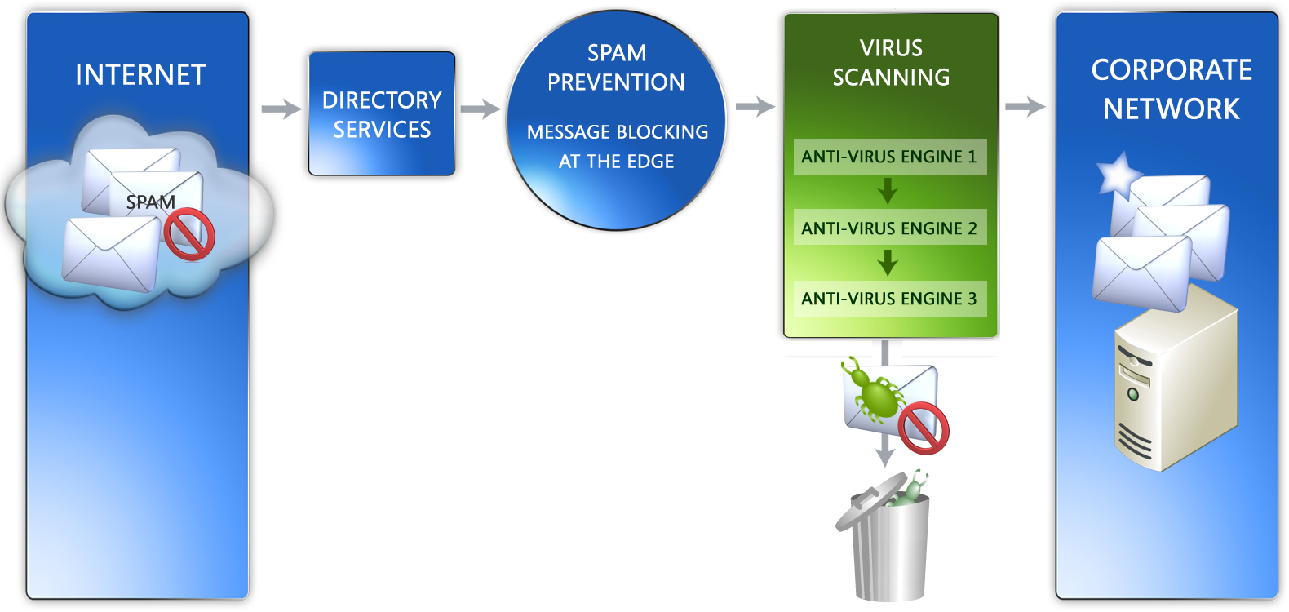
Figure 1-5: FrontBridge’s Anti-Virus Filters

Policy Enforcement
The fourth product that FrontBridge offers in its integrated approach to message security is Policy Enforcement. This allows companies to automatically monitor outbound and inbound email, and stop sensitive and inappropriate messages from leaving and entering the corporate network. Administrators put into effect custom policy rules that include one or more of the following attributes:
• Words and phases in the subject and body
• Message size
• Attachment types
• Number of recipients
• Sender and recipient addresses
• IP address or domain name
Administrators define and edit attribute and policy rules using an easy-to-use, Web-based Rule Writer in the Admin Center, where they specify the type of rule and message rule parameters. They can also indicate when a rule is to expire, if at all. Administrators can also attach disclaimers on outbound email if it flags a rule, with a different disclaimer per domain. This protects the reputation of FrontBridge’s customers by preventing them from being the source of damaging viruses that in turn infect the systems of their customers, partners, and suppliers.
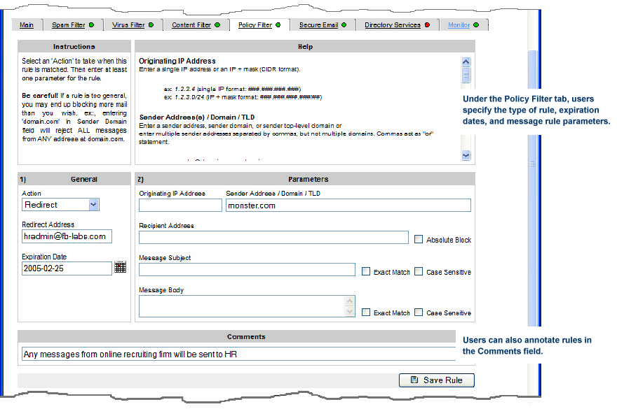
Figure 1-7: The Admin Center Policy Rule Writer
Policy Enforcement can be an important and effective tool in reducing vulnerability to viruses by filtering specific kinds of attachments and email based on know virus characteristics. For example, by leveraging the functionality of Policy Enforcement together with Directory Services to provide select access to executable content by small user populations, a company can eliminate risk for 98 percent of its users.
Message Handling
Administrators have multiple options for handling email that is flagged by a policy rule. Should a message be flagged by a rule, options for handling that message include:
• Reject message
• Allow message
• Quarantine message for review
• Redirect message to an alternate recipient or mailbox
• Deliver message with BCC
• Encrypt message (requires FrontBridge Secure Email)

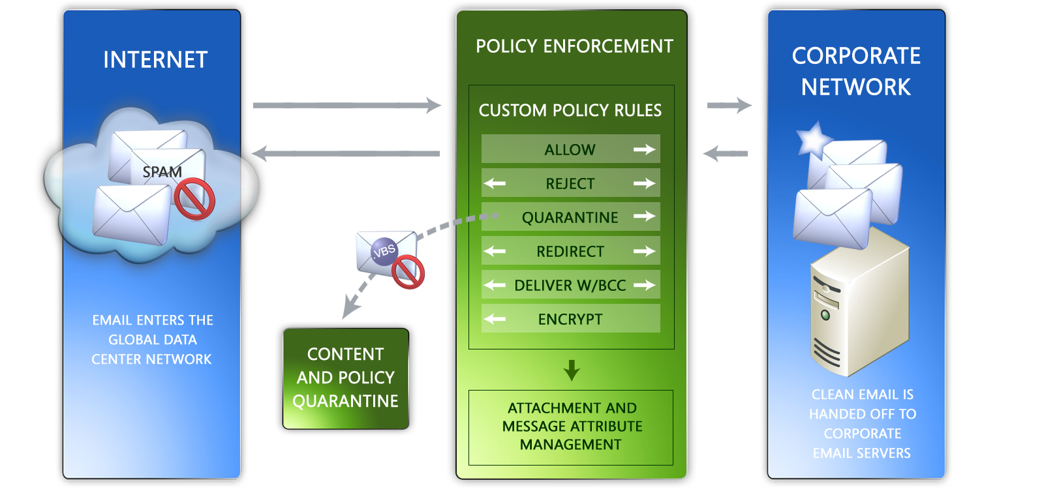
Figure 1-8: Policy Enforcement Features

Once policy rules have been put into effect, messages that trigger a rule are handled according to the rule specifications. If Administrators choose to quarantine messages for review, FrontBridge provides the option to let either users or Administrators review and release quarantined items at their discretion.
FrontBridge also includes standard bounce options. Once an email is rejected for not complying with content and policy rules, Administrators can use the Admin Center Policy Rule Writer to set up separate custom bounce messages for the sender, recipient, and Administrator.
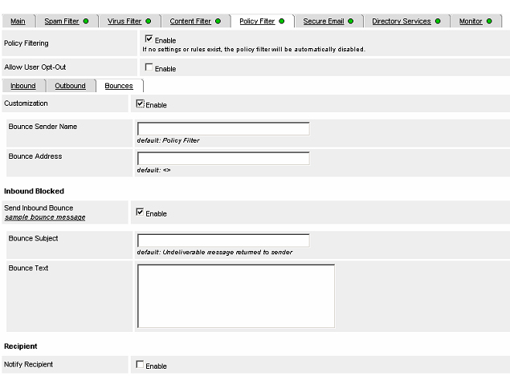
Figure 1-9: Create Custom Bounce Messages

Disaster Recovery
If a customer’s email server(s) becomes unavailable for any reason, FrontBridge ensures no email is lost or bounced. FrontBridge’s servers securely spool and queue email for up to five days. Once email server(s) are restored, all queued email is automatically forwarded in a “flow-controlled” fashion. In cases of extended downtime, email can be rerouted to another server, or made available through a Web-based interface.
The system can be set up to provide deferral notification in the event that email can not be delivered to the customer’s site, sending a text-based page to an Administrator if email is unable to be delivered.

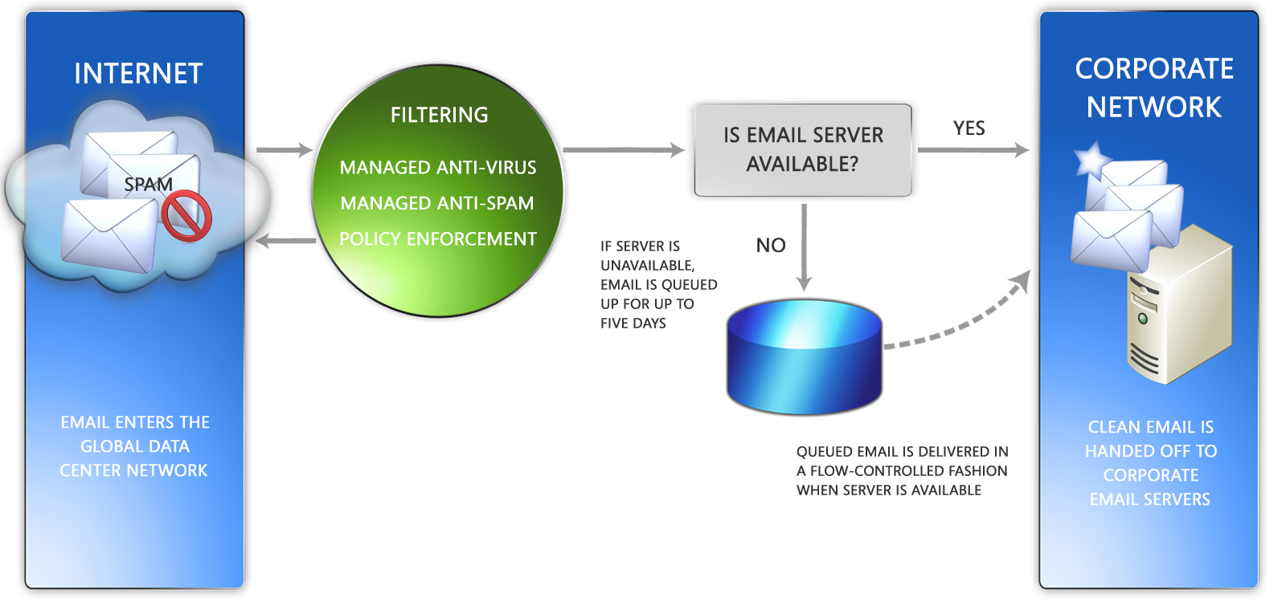
Figure 1-10: Disaster Recovery Queue

FrontBridge’s Global Customer Support Center (GCSC)
More than 3,000 global businesses rely upon FrontBridge’s support infrastructure for timely resolution to the most difficult challenges. To meet these challenges, FrontBridge delivers multifaceted support systems featuring detailed online resources, round-the-clock call centers, and dedicated account management teams. Customers can tap into the GCSC by phone or email 24/7 to reach FrontBridge’s technical engineering staff, ensuring the fastest response to any technical question.
Technical Support
FrontBridge’s technical support staff is on standby 24/7, ready to deliver solutions quickly and clearly. Available via phone or email, the technical support staff can be reached with ease and will stay in close contact with a client until the matter is resolved. FrontBridge also offers online support tools, including FAQs and step-by-step guides.
Technical Account Manager (TAM)
For qualifying customers, FrontBridge offers dedicated Technical Account Managers (TAMs). TAMs work closely with customers to manage the growth of the organization, to plan for the future, and offer additional support to FrontBridge’s technical engineers. TAMs enhance customer relationships by providing an additional layer of strategic and critical planning. From trial to production, TAMs focus on a customer’s business. They work closely with clients to ensure that, as an organization’s needs develop, FrontBridge continues to add tangible value.

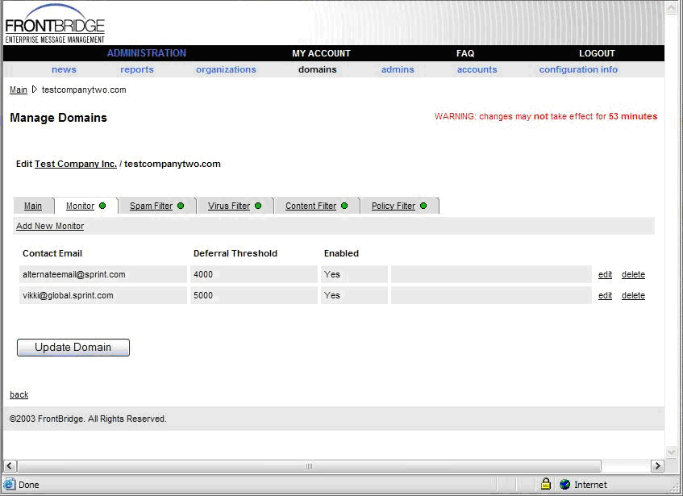
Figure 1-11: Monitoring Configuration Screen

Implementation and Administration
Ease of Implementation
With a simple configuration change, companies can begin using FrontBridge Email Protection Services and be up and running in less than an hour. There is no hardware to provision; no software to buy, install or configure; and no expensive training required for IT staff.
Within 24 hours upon receipt of signed contract, a representative from the GCSC contacts the customer to set a date for Implementation¹, which is typically completed in a two-step process:
Step 1
A simple change is made to the customer’s mail exchange (MX) record without the use of additional hardware and software. The customer’s original MX record (such as mail.customer.com) is replaced with a pointer to the FrontBridge network (mail.global.FrontBridge.com). Over the following 24 hours, this change is propagated throughout the Internet and mail begins to flow through the FrontBridge network to corporate email servers. As soon as the customer is set up, the TAM then provides one hour of training on the Admin Center.
Step 2
Customer servers are configured to only accept the IP connections from the FrontBridge network of data centers 72 hours after the MX record change. If the customer is utilizing outbound services, their servers are configured to send all outgoing mail to the FrontBridge network.
Admin Center
The FrontBridge Admin Center is a Web-based console for defining and managing the settings and configuration for customer domains. During implementation of FrontBridge’s services, the client services team conducts a one-on-one walkthrough with new customers to familiarize Administrators with the Admin Center console and tools. After the walkthrough, customers can access the Admin Center any time of the day or night. Administrators can log in to the Admin Center through the following URL: http://www.frontbridge.com/login/login.php
The Admin Center allows Administrators to define and edit a variety of rules and settings.
A news page in the Admin Center updates customers on important information, such as new services, system upgrades, virus outbreaks and patches.

_______________________________
¹A confirmation email is sent to the customer with the agreed upon date and time for implementation. Attached to the email is the Admin Center Tutorial, the Security Checklist (MX record change instructions), and support contact information.
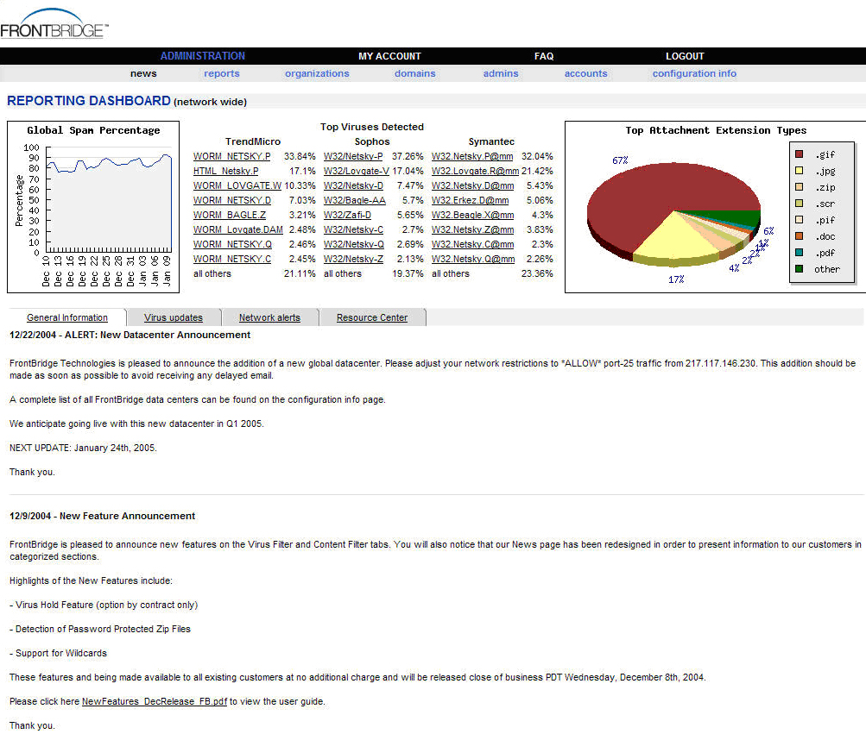
Figure 1-12: Admin Center Dashboard
Reporting and Analytics
The Admin Center also provides access to a set of comprehensive reports that give a detailed view into the use of a customer’s email system. Reports can be generated by domain and by organization (including all domains) and provide information such as top spam recipients, top virus recipients, percentage of inbound email flagged as spam, and overall email volumes.
Accessible via the Web, this suite of reports provide a detailed view into the statistics and use of an email system. Measured on an hourly, daily, weekly, and monthly basis, these reports are a valuable tool for gaining insight and control of any customer email system.
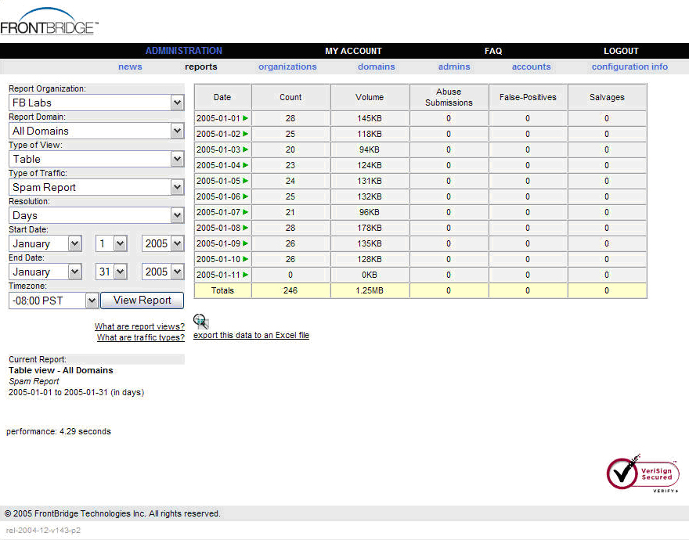
Figure 1-13: The Admin Center Reporting Console

FrontBridge reports include:
Delivery Report: The number of inbound messages and message volume (in megabytes) delivered for a domain; statistics are available by month, date, and hour.
Outgoing Mail Report: For customers using FrontBridge’s Outbound Services, this report details the number and volume of messages sent; statistics are available by month, date, and hour.
Spam & Submissions Report: The number and volume of messages identified as spam by the filtering service or submitted by end users as false positives or false negatives; data is reported by month, day, and hour.
Rejection Report: The number and volume of messages rejected by various filters including customer-defined filters; data is reported by month, day, and hour.
Virus Report: The number and volume of inbound files scanned, and the number of viruses detected and cleaned; data is reported by month, day, and hour. This report also provides additional details about senders and recipients of viruses, virus file name, and links to virus background information provided by FrontBridge’s antivirus partners.
Outbound Virus Report: The number and volume of outbound files scanned, and the number of viruses detected and cleaned; data is reported by month, day, and hour. This report also provides additional details about senders and recipients of viruses, virus file name, and links to virus background information provided by FrontBridge’s antivirus partners. Applies to Outbound customers only.
Deferral Report: The number and volume of messages deferred for delivery when a customer has a mail server outage; statistics are reported by month, date, and hour.
Top Report: Shows the top 5, 10, 15, 20, or 25 users that are top mail recipients, top mail senders, top spam receivers, top virus recipients, and most viruses received.
Master Report: Summarizes all email traffic for a customer’s domain.
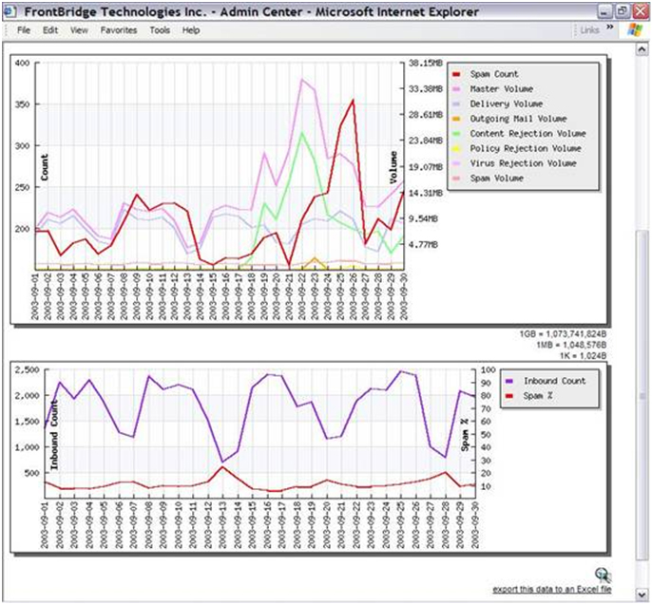
Figure 1-14: Sample Report, Graph Format

About FrontBridge Technologies, a Microsoft Subsidiary
FrontBridge Technologies, a Microsoft subsidiary, offers managed messaging services for enforcing email compliance with encryption and archiving tools, providing email availability through a web-based back up, and improving protection of employee inboxes from viruses and spam. Its complete line of services includes message archiving, spam and virus filtering, disaster recovery, and email encryption and supports multiple e-mail platforms such as Microsoft® Exchange, IBM Lotus Domino, and other SMTP-compliant servers. These managed services provide value to corporate customers by requiring no upfront capital investment, minimizing IT management overhead, and removing incoming email threats before they reach the corporate firewall. FrontBridge is now part of Microsoft’s Exchange Server Group. For more information, visit http://www.microsoft.com/exchange

Related Links
See the following resources for further information:
- FrontBridge, a Microsoft Subsidiary at http://www.frontbridge.com
- Microsoft Exchange Server at http://www.microsoft.com/exchange
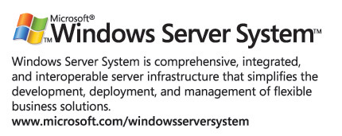
For the latest information about Windows Server System, see the Windows Server System Web site at http://www.microsoft.com/windowsserversystem.

