
FRONTBRIDGE SERVICES OVERVIEW
FrontBridge offers the broadest range of best-of-breed messaging services to help organizations increase the performance, reliability, security and control of their existing messaging system, while reducing costs.  OFFERINGS  FrontBridge E-Mail Filtering – Protect against e-mail-borne threats with multilayered defenses against spam and viruses, e-mail policy enforcement, and protection against e-mail server outages  FrontBridge Message Archive –Comply with regulatory and corporate governance requirements with e-mail retention, monitoring and retrieval  FrontBridge Active Message Continuity – Provide always-on access to e-mail with web-based back-up e-mail system  FrontBridge Secure E-Mail – Encrypt sensitive corporate information and comply with privacy regulations  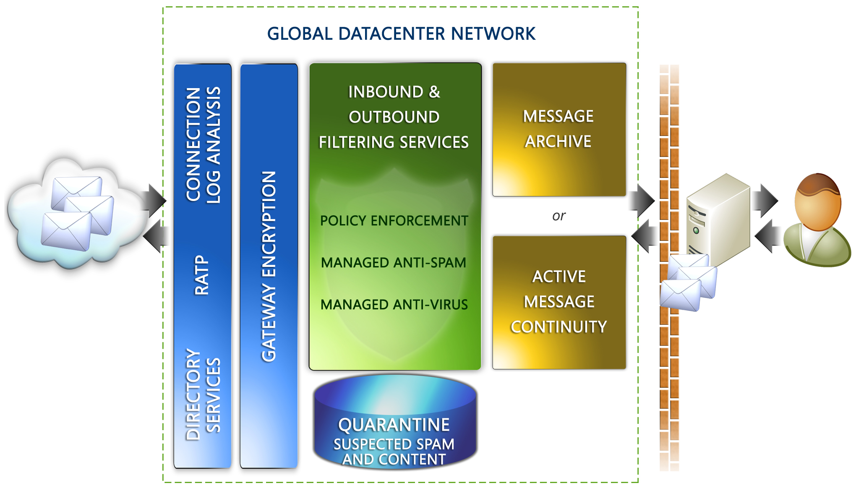  BENEFITS
  Manage Cost and Complexity  - Services deployed “in the cloud,” requiring no upfront capital investment  - Minimal IT administration enabling staff to focus on value producing projects  - Multiple services available through a single provider  - Predictable service subscription model | Secure, Protect and Comply  - Multi-layer approach to anti-spam and anti-virus  - Centralized content and policy administration  - Eliminate threats before they reach the corporate firewall  - Real-time attack protection and prevention  - Off-site e-mail indexing and archiving for compliance | Maximize Inbox Availability and Access  - Most reliable global network of data centers performance-backed by Service Level Agreements  - Web-based access to service administration  - Fully-functional back-up e-mail system for disaster recovery
  FREE TRIAL
  Sign up today!
  www.frontbridge.com/trial
  HOW IT WORKS
  FrontBridge services are driven by a global network of data centers. Within this network, FrontBridge delivers a comprehensive set of services that creates a secure, protected, and compliant message stream to and from your on-premise messaging infrastructure.
  E-mail has inherent vulnerabilities because firewalls must leave a communications port open for e-mail, exposing this open port as a channel for malicious content.
  FrontBridge shields companies from this vulnerability, providing a buffer against e-mail-borne attacks. Our globally load-balanced network delivers unmatched availability, security and confidentiality.
  Unlike competitors who claim global coverage but provide access to one or two data centers, FrontBridge provides access to all eight of its data centers. Functioning as peers, these data centers distribute mail so there is never an isolated point of entry or exit.
  In the unlikely event that a data center is unavailable, mail is dynamically and intelligently routed to the peer centers, resulting in efficient delivery of e-mail all the time, for every customer.
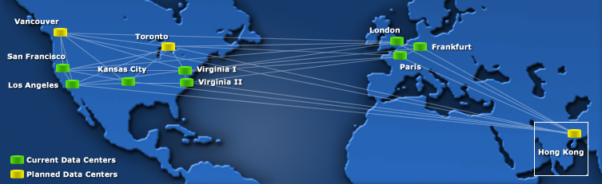  COMMONLY ASKED QUESTIONS  Q: What must I do to start using FrontBridge services?  A: Upon signing a service agreement, a FrontBridge Client Service representative will walk you through the set-up procedures. During your orientation, the representative will provide information about changing your MX record to point to our mail network. After that step, there is no hardware or software to install.  Q: I have locally installed protection for spam and viruses on my e-mail system. Why do I need a managed service?  A: In short, a managed service, such as FrontBridge, provides a frontline of defense against spam, viruses and other e-mail borne threats. Working in concert with your locally-installed spam and virus protection, a managed service filters bad and dangerous e-mail from your message stream before it reaches your corporate network. The FrontBridge service operates from a global, load-balanced network that can respond to large fluctuations in e-mail volume, unlike other services or premised-based solutions.  Further FrontBridge integrates valuable services such as policy enforcement, e-mail archiving, e-mail continuity, and e-mail encryption to give you complete protection and control over messages entering and exiting your corporate network.  Q: Why is FrontBridge Message Archive better than other e-mail archive solutions?  A: FrontBridge Message Archive has three significant advantages that make it a superior message archiving solution:  - Message Archive intercepts all inbound and outbound e-mail, and works in conjunction with FrontBridge inbound and outbound message filtering, to clean the message stream of unwanted content before it is indexed and archived.  - Message Archive was built with the most stringent and e-mail regulations in mind. To comply with SEC Rule 17a-4, NASD Rules 3010 and 3110, and Sarbanes-Oxley, Message Archive captures all electronic communications for customers, uniquely serializes every message and archives those messages in fully redundant, live databases.  - Message Archive archives multiple message types, including e-mail, instant messages, Bloomberg Mail. All messages are stored in the same database for easy monitoring, search and retrieval across all message types.  Q: How do FrontBridge Message Archive and Active Message Continuity ensure continuous operation of e-mail for my system’s users?  A: Message Archive and AMC enable uninterrupted e-mail continuity, leveraging the underlying archiving technology of these services to provide a failsafe store of all messages sent and received. In the event that an organization’s primary e-mail system fails, end users can continue to receive, read, respond to, forward and create new e-mail through the rich Web-based interface.
  ANALYST PERSPECTIVE
  “Security, compliance and business continuity requirements in industries such as healthcare and financial services are placing greater demands on the messaging infrastructure. It’s not enough to handle these challenges with a growing array of standalone appliances or point solutions. Managed services are a fundamentally sound method for deploying multiple, integrated services.”
  Michael Osterman,
  President and founder,
  Osterman Research
  ABOUT FRONTBRIDGE
  FrontBridge Technologies, a Microsoft subsidiary, offers managed messaging services for enforcing email compliance with encryption and archiving tools, providing email availability through a web-based back up, and improving protection of employee inboxes from viruses and spam. Its complete line of services includes message archiving, spam and virus filtering, disaster recovery, and email encryption and supports multiple e-mail platforms such as Microsoft® Exchange, IBM Lotus Domino, and other SMTP-compliant servers. These managed services provide value to corporate customers by requiring no upfront capital investment, minimizing IT management overhead, and removing incoming email threats before they reach the corporate firewall. FrontBridge is now part of Microsoft’s Exchange Server Group. For more information, visit http://www.microsoft.com/exchange
  FREE TRIAL
  Sign up today!
  www.frontbridge.com/trial
The information contained in this document represents the current view of Microsoft Corporation on the issues discussed as of the date of publication. This document is for informational purposes only. MICROSOFT MAKES NO WARRANTIES, EXPRESS OR IMPLIED, IN THIS DOCUMENT. © 2005 Microsoft Corporation. All rights reserved.

